Gathering Data from the Economic Report of the President

Accompanying Excel workbook for this document: EconomicReportDataAnalysis.xls

The Economic Report of the President is well known for containing thoughtful analyses of economic policy written by members of the President’s Council of Economic Advisors. But this annual report is also a good source of macroeconomic data. Data contained in the appendices of the report are available on online. This national data is excellent for examining time-course trends in many areas of the economy.
We will explore the ERP website and data downloading capabilities via an example. We will attempt to recreate a “plain-vanilla” macroeconomic relationship originally studied by Henry Allen Latanè, but updated by Carl F. Christ (1993). Latanè obtained these estimates in a regression of the inverse of the GNP velocity of money (the ratio of the money stock to GNP) on the inverse of a long-term, high-grade bond rate (RL) for the years 1919-52:

M1/GNP = 0.100 + .795/RL R² = 0.75.

Christ estimated essentially the same relationship for the period 1959-1992, replacing GNP with GNP and RL with a different measure of long-term interest rates and reported the following results:
M1/GDP = 0.086 + .771/RAaa R² = 0.91.

This regression is based on annual data from 1959 to 1991. The variables are defined more precisely as follows:
M1 | currency plus checkable deposits in billions of dollars
GDP | Gross domestic product, billions of dollars
RAaa | Moody’s Aaa corporate bond rate, percent per year

Christ’s source was the Economic Report of the President, 1992, pp. 298, 320, and 378.

To recreate this equation and regression, therefore, we need to gather three data sets; M1 money supply, Gross Domestic Product, and Moody’s Aaa Corporate Bond rate. We will collect these data and attempt to recreate the regression reported above (1959-1991) as well as examine an updated regression (1959-2003).

The ERP Website
The main page for the Economic Report of the President is located at www.gpoaccess.gov/eop/. The link to “Downloadable Reports/Tables” is located on the left-hand side of that Website directly under the seal of the President of the United States. That link will bring you too the main download page where you can download the complete report from past years (in .pdf format) or single data sets. We will explore the data sets from 2004:
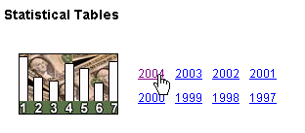
The page presents a list of about 115 tables, all dealing with a different sector of the U.S. economy. Unfortunately, other than the title of each chart, no detailed descriptions are available outside the main report. This means that you will have to explore and search for particular variables. For this example we have already identified the three tables that we need to download:

- B-1. Gross domestic product, 1959-2003
- B-69. Money stock and debt measures, 1959-2003
- B-73. Bond yields and interest rates, 1929-2003

Fortunately, the tables are already in Excel format; thus we simply need to save them to an appropriate file. To do this, right-click on the links and select “Save Target As.” Each file will save as a Microsoft Excel worksheet. You do not have to convert the file from text or some other format.

Customizing Your Data

Although the data are presented in Excel workbooks, you will have to make some alterations before the data become useable. The tables are quite complicated and often you must carefully choose which data to use. In the following picture, for example, we see a portion of Table B-69, Money stock and debt measures. For our formula we need data on M1, but as the picture below shows, there are two measures pertaining to M1 within the first six columns of the table.

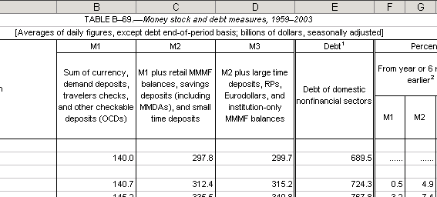

In fact, we need to use column B.
We have found it easiest to highlight the data we wish to use (e.g. the solumn B containing the M1 series) and to copy it into a new Excel sheet. In our example, we need one column from each of the tables we downloaded and the corresponding years. See EconomicReportDataAnalysis.xls for further examples.
Once you have compiled all of your data in a single sheet, there are a few formatting tasks that must be completed before you can analyze the data. First you must standardize the years. In our example, bond data dates back to 1929, but we only want data from 1959. You must also be sure that your time periods remain consistent. For example, GDP data turns from yearly to quarterly data in 1999. Frequently, there are spaces or empty rows separating decades. These empty rows should be removed before you attempt any analysis. For more examples of formatting issues and how to handle them, see the RawData sheet in EconomicReportDataAnalysis.xls.
Now that we have useable data we can attempt to recreate Christ’s regression. His results were:
M1/GDP = 0.086 + .771/RAaa r² = 0.91

Using the series on M1, GDP, and RAaa, we need to create two new columns, M1/GDP and 1/RAaa. Next we run a regression with 1/RAaa as the independent and M1/GDP as the dependent variable. This analysis along with a few others is available in EconomicReportDataAnalysis.xls. Our results are below:

M1/GDP = 0.080 + .769/RAaa R² = 0.91

Why are our results different from Christ’s? The reason is that government agencies frequently revise their data. Thus, GDP data for 1959-1991 contained in the 2004 Economic Report of the President is slightly different from GDP data for the same period published in the 1992 Economic Report of the President. It is possible to obtain data series back to 1997 in electronic form at the ERP website. To learn more about how economists deal with the problem of replicating papers which use data series that are frequently revised, see RTDSM.doc in the \Basic Tools\InternetData\RTDSM folder. This document discusses the Real-Time Data Set for Macroeconomists produced by the Federal Reserve Bank of Philadelphia, which contains data sets as they were in the past.

Conclusion
The Economic Report of the President is a useful resource for macroeconomic time series data, but it requires the user to be careful. This document has illustrated how to download and reformat data in order to make it usable.

Christ, C.F. (1993) “Assessing Applied Econometric Results.” The Federal Reserve Bank of St. Louis Review, 75(2): 71-94. Available at <research.stlouisfed.org/publications/review/past/>.

