Installing and Using the Histogram Excel Add-in

Software for

Introductory Econometrics

By
Humberto Barreto and Frank M. Howland
barretoh@wabash.edu and howlandf@wabash.edu
(765) 361-6315 and (765) 361-6317

WARNING:
This software was written and designed for teaching purposes. It has been tested on several examples but not on a wide variety of data sets. For mission-critical projects, always check the results with full-fledged statistical programs.

The Histogram add-in is Histogram.xla (on the CD-ROM, it is in BasicTools\ExcelAdd-Ins\Histogram).

PURPOSE OF THIS DOCUMENT

This document describes how to install and use the Excel add-in Histogram.xla, which can be used to create histograms for univariate and bivariate data sets. The data can be located in columns or rows or blocks and it can include missing values. This add-in also reports summary statistics on the variable, including the number of observations, the number of missing observations, the number of unique values, and the mean, standard deviation, minimum, maximum, median, and 25th and 75th percentiles. In addition, the add-in will optionally print out a frequency table. Finally, it is possible to, within certain limits, adjust the number of bins in the histogram for single variable applications, though this feature does not work if there are missing values.

INSTALLING AND LOADING

Microsoft offers the following description of an Excel add-in:

Add-ins are programs that add optional commands and features to Microsoft Excel. Before you can use an add-in, you must install it on your computer and then load it in Microsoft Excel. Add-ins (*.xla files) are installed by default in the Library folder in the Microsoft Excel folder. Loading an add-in makes the feature available in Microsoft Excel and adds any associated commands to the appropriate menus. [Microsoft Excel Help, add-ins, overview]

Thus, to install an add-in is to have an add-in file (*.xla) in the Library folder of your hard drive. To load it, you must complete an additional step using the Add-In Manager. Fortunately, you need to do this only once.

Step 1: Installing the Histogram.xla file

If you are accessing the Histogram.xla add-in from a CD-ROM, place the CD in your computer. If accessing from a network server, make sure you can read from the appropriate network drive.

If you do not have CD-ROM or network access to the Histogram.xla add-in, download it by visiting <www.wabash.edu/econometrics>. Download the Histogram.xla file directly to the appropriate add-ins folder on your hard drive (usually, C:/Program Files/MicrosoftOffice/Office/Library) or move it there after downloading to your hard drive.

Step 2: Loading The Histogram.xla add-in

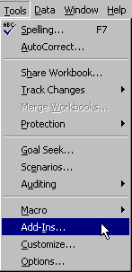
Once the Histogram.xla file is accessible, launch Excel and use the Add-In Manager to load the Histogram add-in. First, open the Add-In Manager by clicking on the Tools menu item and selecting Add-Ins.

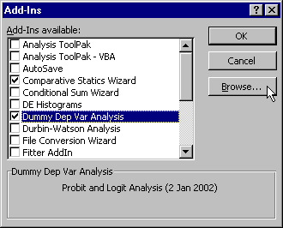

If the Histogram add-in is not listed in the Add-Ins scroll box (as in the example above), click the Browse (or Select) button, navigate to the Histogram.xla file on the CD-ROM or network drive, select it, and click OK.
Mac Note: Some versions of OfficeX report, “Unable to Copy add-in to the Add-ins folder.” This is a bug. The add-in really is there. Simply quit Excel, then restart it, return to the Add-In Manager, and continue following the instructions.

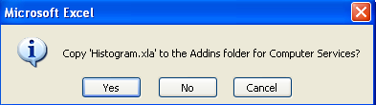

Click OK if you are asked to write the Histogram.xla file to the Addins (or Library) folder. The Add-In Manager dialog box will now list the Histogram add-in.

The Add-In Manager lists all of the installed add-ins, and those with checkmarks are also loaded. Microsoft offers the following advice, “To conserve memory, unload add-ins you do not use often. Unloading an add-in removes its features and commands from Microsoft Excel, but the add-in program remains on your computer so you can easily load it again.” [Microsoft Excel Help, add-ins, overview]

Make sure to select the check box next to the Histogram add-in and click OK.

Excel will load the Histogram.xla file and notify you of successful installation with the following message:

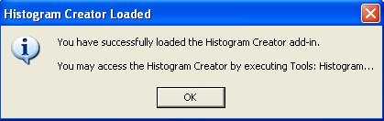

USING THE HISTOGRAM.XLA ADD-IN:

Using the Histogram add-in is easy. Execute Tools: Histogram . . . to get the following form:

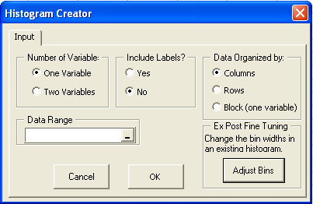
Click here to make the dialog box collapse so you can see the sheet.

Choose the number of variables. You can draw a single-variable histogram or a superimposed pair of histograms – one for each of two variables.

Decide whether or not to include labels. The labels need to be located in the first row or first column of the data.

Inform Histogram Creator how the data are organized. Usually data will be organized in columns, but the software can handle data in rows or all in one contiguous block.

Select the Data Range by clicking on the desired cells and dragging. As you do, the selected cells appear in the Data Range input box.

Click OK to proceed. You are presented with a second form:

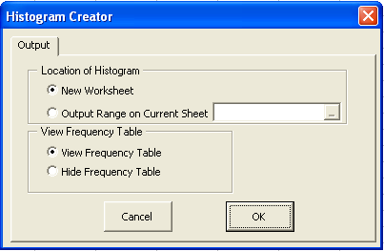

You may output the histogram and other results to a new worksheet or in an empty area of the current sheet. If you choose the latter, you will be warned if the output will overwrite existing data.

Choose the View Frequency Table option if you want a list of the number of observations in each bin of the histogram.

Click OK to produce the histogram.

The output looks like this for a one-variable histogram:

Here is an example of the two-variable histogram output.

If you have elected to put the histogram in a new worksheet, then you can use the Adjust Bins button to control the bin width. From the sheet with your histogram, execute Tools: Histogram and click on the Adjust Bins button.
A small control, 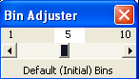, pops up on your screen that allows you to alter the size of the bins by simply dragging a slider left or right. By dragging the slider all the way to the right, the histogram above is altered to display ten bins instead of five:
Adjust Bins is enabled only for histograms outputted to a new worksheet.
To obtain even narrower bins, simply execute Tools: Histogram again and click the Adjust Bins button. The current number of bins always appears in the center, and so you can easily obtain ever finer (or coarser) bin widths.

Note that when you use the Adjust Bins option all the class intervals include the left endpoint, but not the right endpoint except for the last bin (with the highest values) which includes all observations in the interval, inclusive of both left and right endpoints.

The histogram is an Excel XYScatter chart with the y-axis suppressed. You can change the axes or titles as you would in a regular Excel chart. Similarly, font and color can be easily adjusted.

The convenient summary statistics makes this add-in a valuable tool for easily displaying descriptive statistics for one or two variables.

ERRORS AND TROUBLESHOOTING

The Histogram add-in has a few simple error checks.

It will complain if you attempt to create a histogram without selecting any data:

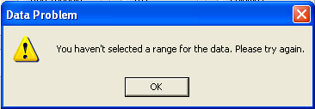

Common errors are trapped, and a message describes what went wrong. For example, this message is displayed if you chose a Two Var histogram but selected a single column of data.

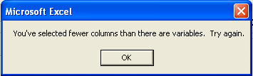

BENCHMARKS FOR THE HISTOGRAM ADD-IN

The file HistogramBenchMark.xls demonstrates the behavior of the add-in for several univariate data sets available from the Statistical Reference Datasets Project at the National Institute of Standards and Technology. The demonstration shows that the summary statistics portion of the add-in does a good job. In particular, the add-in is robust to difficult computations of the standard deviation.
THIS VERSION
The latest Histogram.xla version is 30 June 2008.

To check the date of your installed add-in, execute Tools: Add-ins and then highlight the add-in. The Add-Ins dialog box displays the date at the bottom.
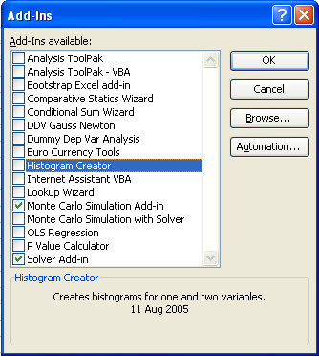
To install this for the first time, please follow the instructions on the first page of this document.

To install over a previous version that is already installed, please see InstallingAddinOverPreviousVersion.doc

To install over a previous version, quit Excel and simply drag this new version into the Excel Add-ins folder. If you do not know where this folder is, search for “Histogram.xla” and then drag the new version over the old one. Of course, you will want to accept rewriting over the previous version.

ADDITIONAL HELP AND FEEDBACK:

If something goes wrong in the installation or loading process, an unexpected error keeps recurring, or you have other problems, please contact us. We are interested in your comments, suggestions, or criticisms of the Histogram.xla software.

www.wabash.edu/econometrics

Humberto Barreto  Wabash College  barretoh@wabash.edu  (765) 361–6315 | Frank Howland  Wabash College  howlandf@wabash.edu  (765) 361–6317

